
Sri Lanka Institute of Information Technology

IT3012 : Intelligent Agents – Lab 5
Y3.S1.WD.AI.01.01
Malabe Campus

Student ID - | IT24100140
Student Name - | Prathiban HTP
Module Name - | Intelligent Agents
Module Number - | IT3012
LabSheet Number - | 5
LabSheet Date - | 2026/Sep/18

Step 1
Step 1.1
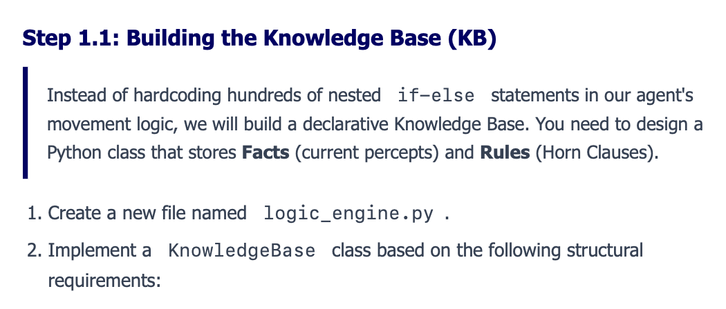
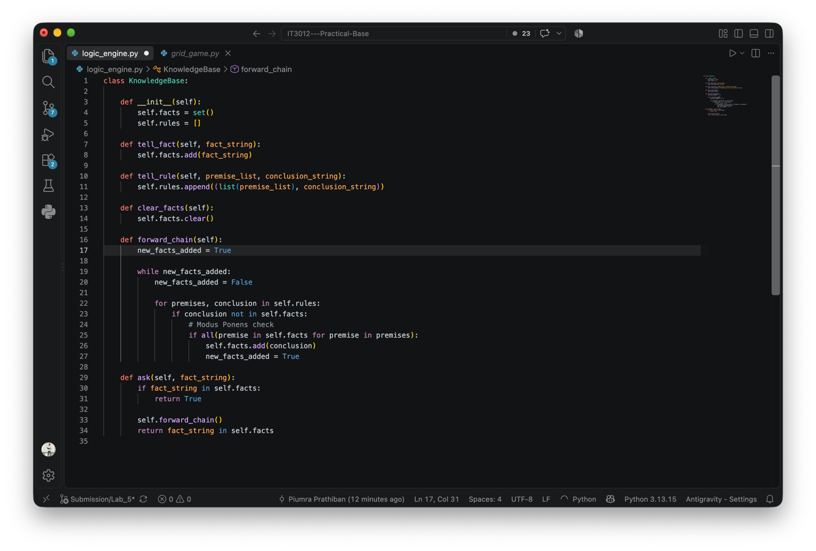

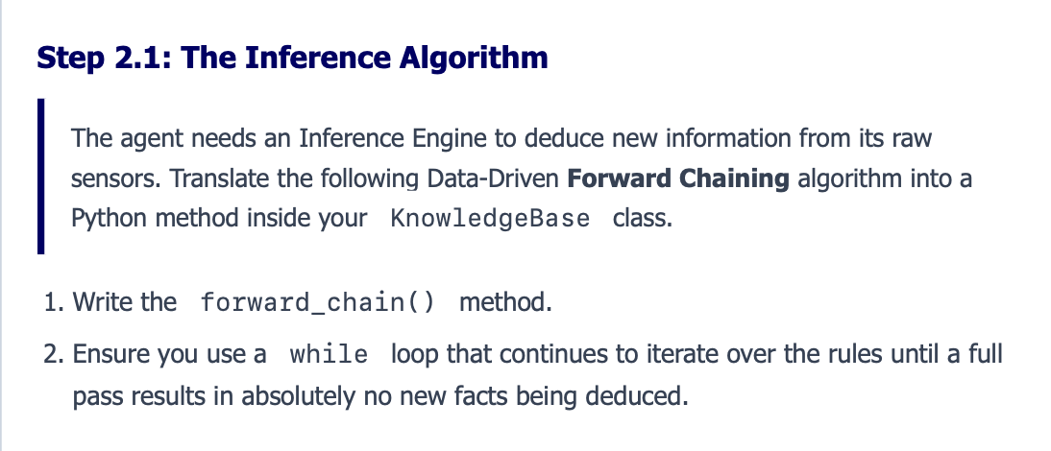
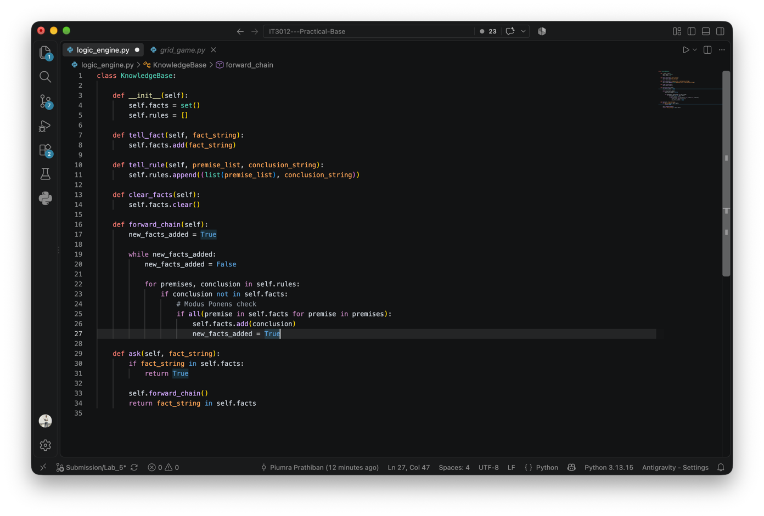

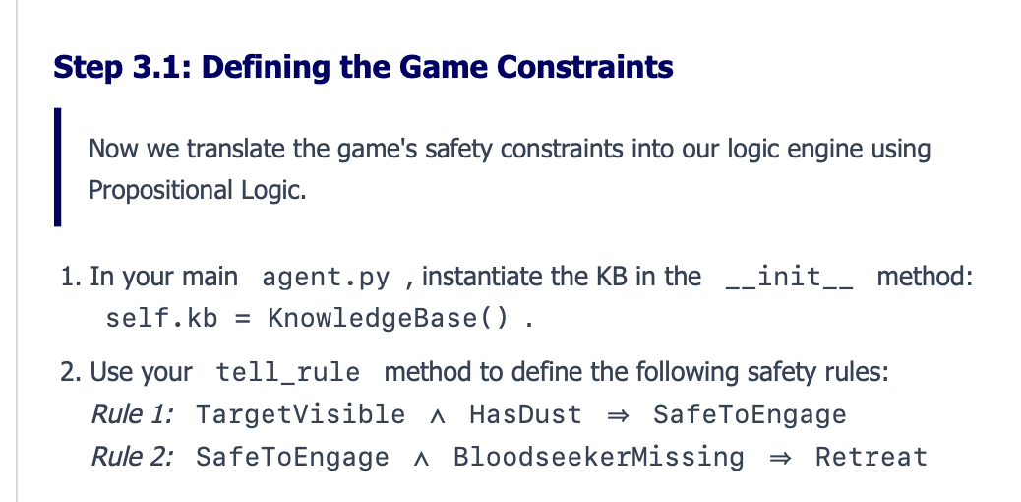

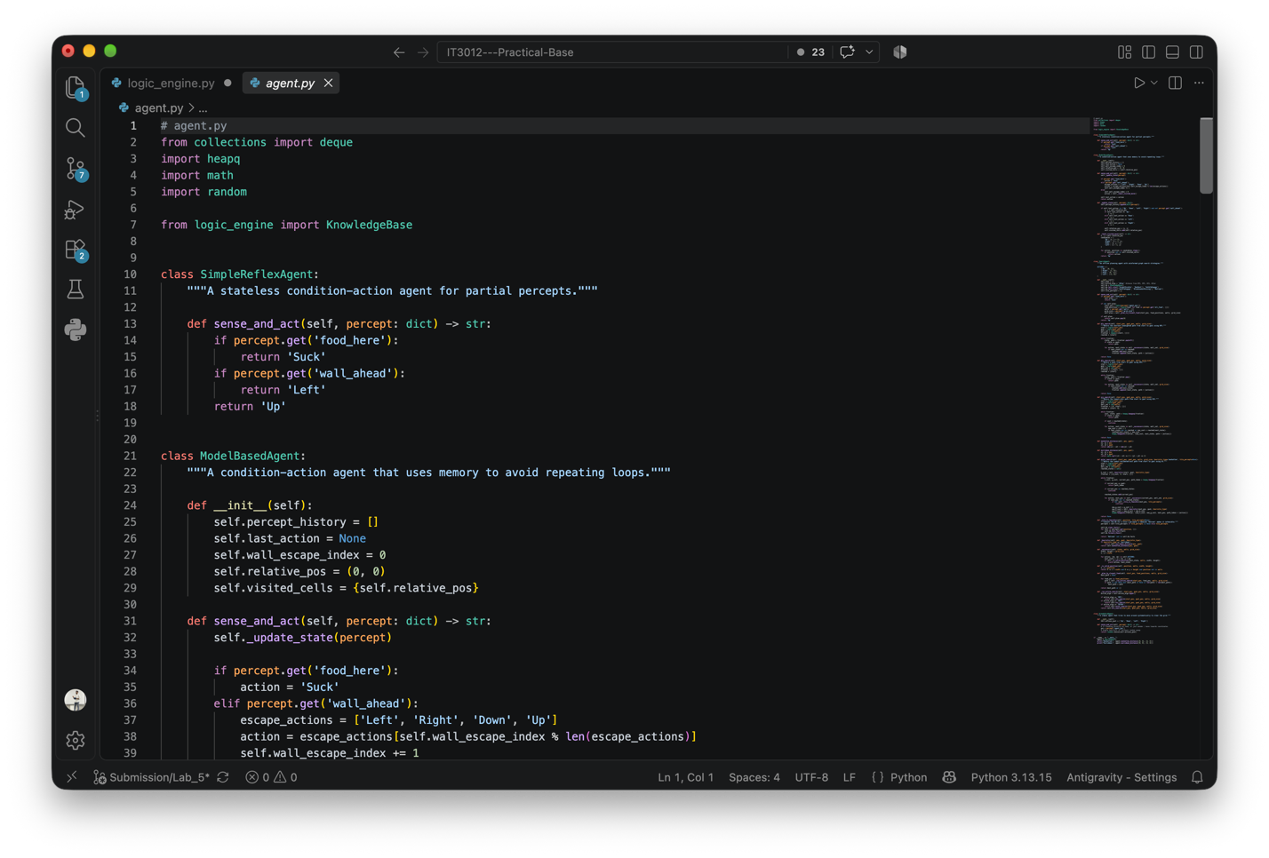

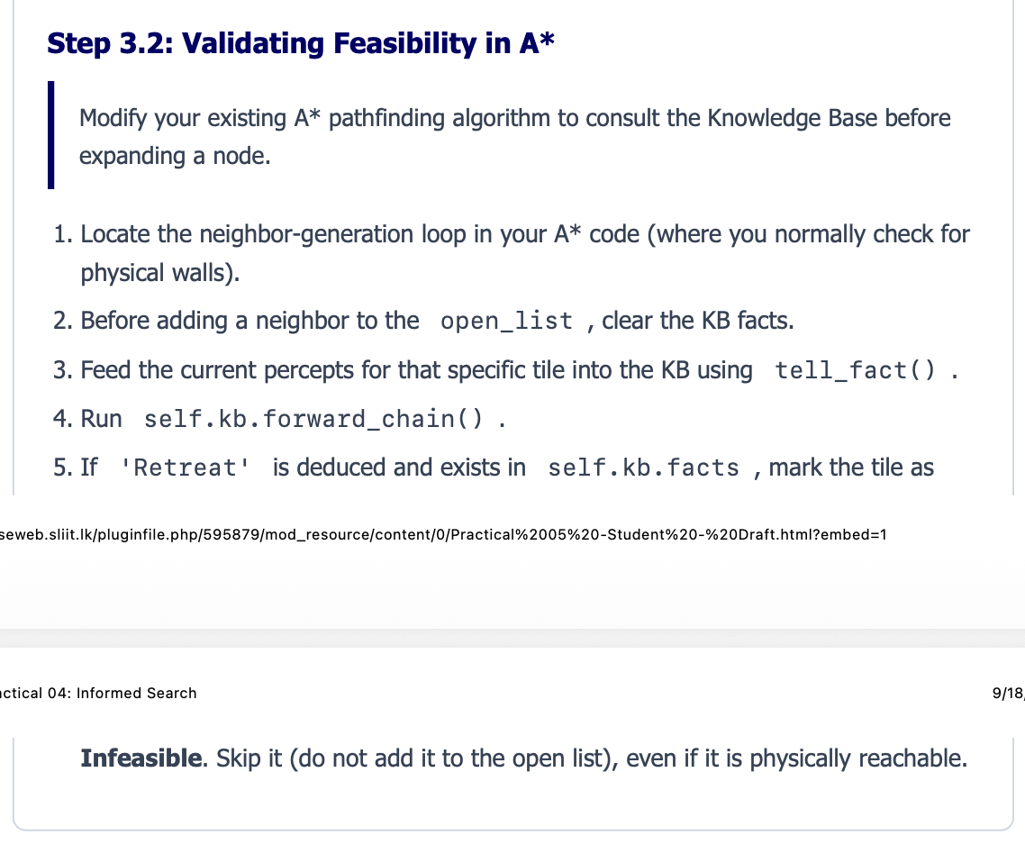

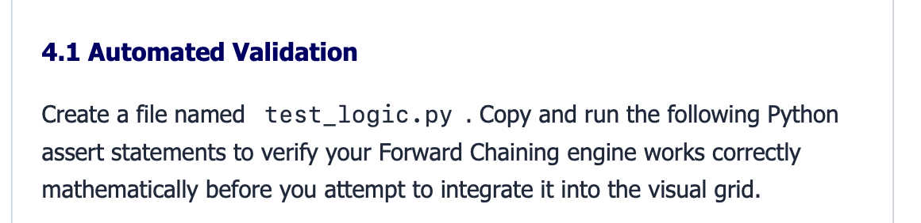

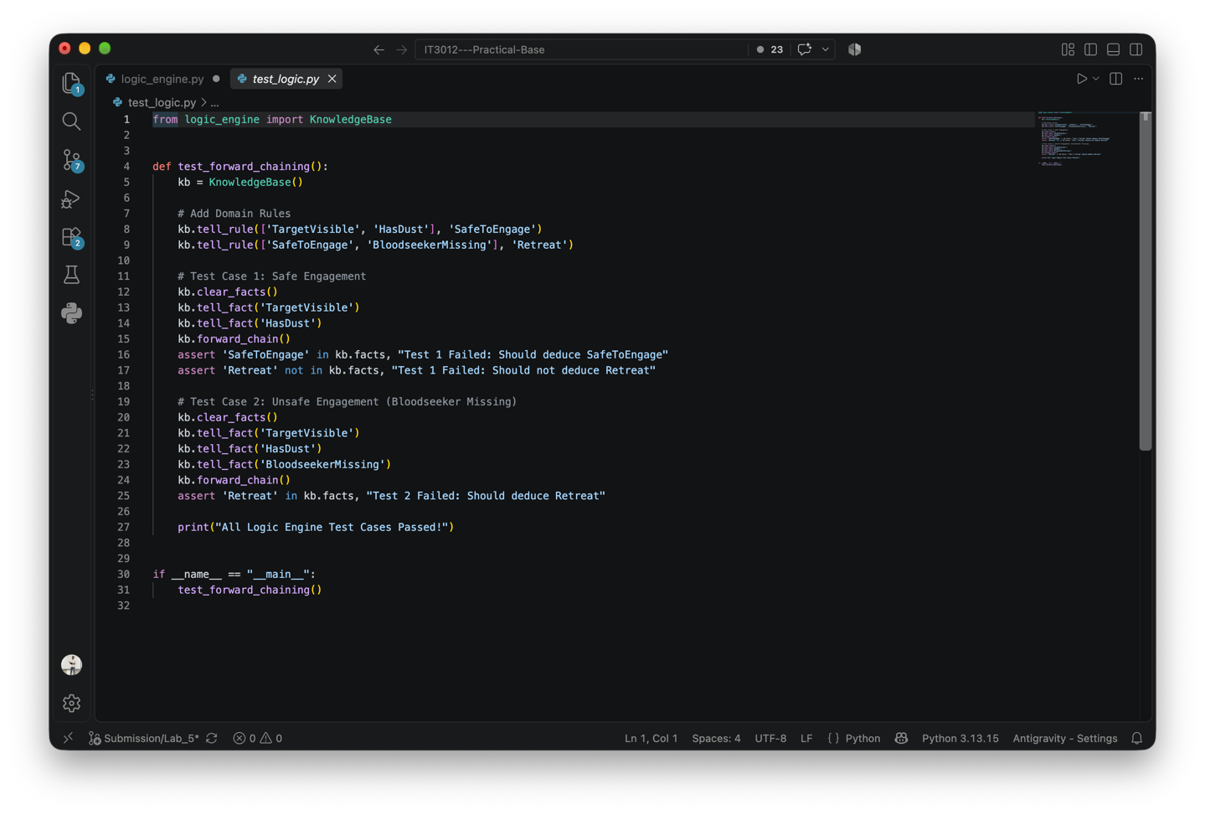

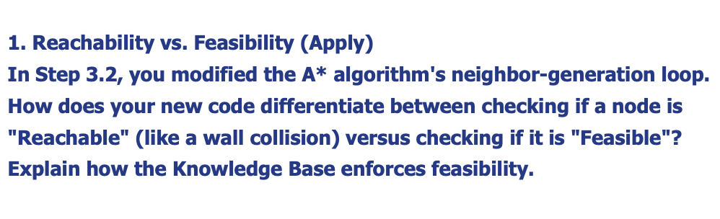
Reachability is physical: _successors() only generates positions that are inside the grid and not walls.
Feasibility is logical: _tile_is_feasible() checks a reachable tile using the Knowledge Base (KB). The KB adds the tile’s percepts, runs forward_chain(), and rejects the tile if Retreat is derived.
Therefore, a tile can be reachable but not feasible. A* checks both before adding the node.
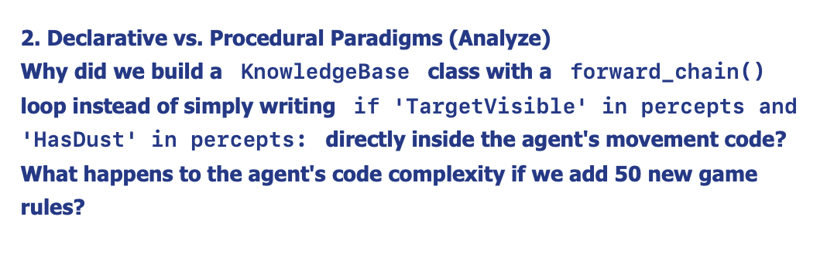
The Knowledge Base keeps rules and facts separate from the agent’s movement code. Instead of adding an ifstatement for every rule, forward_chain() applies all rules generically.
This makes the system easier to extend: adding 50 new rules only requires adding the rules to the KB, without making the movement code more complex. The inference engine remains the same.

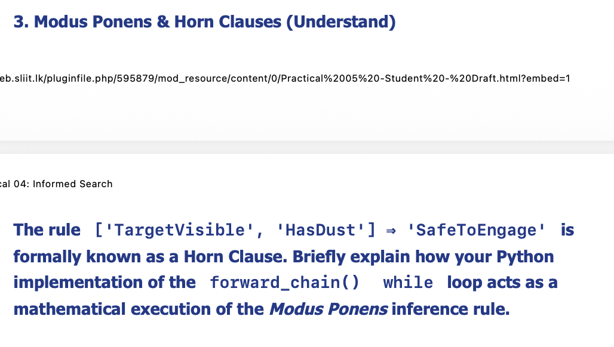
The rule:
['TargetVisible', 'HasDust'] ⇒ 'SafeToEngage'
is a Horn clause. Modus Ponens states that if all premises are true and they imply a conclusion, we can infer that conclusion.
In forward_chain():
if all(p in self.facts for p in premises):
checks that all premises are known, and:
self.facts.add(conclusion)
derives the conclusion.
The while loop repeats this process until no new facts are added, allowing derived facts to trigger further rules.

